Dillon Scholarship
The scholarship was established by BayTrust over 25 years ago. It was named after the late Ray Dillon, former Chairman of the Trust who was well known for his active support of people with disabilities.
The purpose of the Dillon Scholarship is to assist students with significant disabilities* to obtain a tertiary education.
Who may apply?
Students with significant disabilities and:
- who are financially disadvantaged during their tertiary education as a result of their disability;
- who are attending (or intend to attend) University / Polytechnic or other New Zealand based institutions recognised by NZQA;
- whose home base is within the Bay of Plenty (refer map below);
- who can provide a medical certificate outlining their condition.
Scholarship Guidelines
- Applications should be made in the year prior to the year of intended tertiary study.
- The amount of the Dillon Scholarship is at the discretion of the Trusts Dillon panel, up to $5,000pa and up to five years of study, assessed annually.
- Scholarship funds will be released to successful applicants on proof of acceptance (e.g. study link receipt where course fees are payable) from their tertiary institution of their choice.
- There is no age limit for applicants.
- For returning applicants, a brief progress report which includes a letter outlining an intention to return to study together with course transcript is required to be sent to the Trust to facilitate a request for another scholarship. The Trust may then contact the applicant to clarify any further information if required.
- Some applicants may be asked to meet with the Dillon Scholarship Panel. The Panel’s decision is final and no correspondence will be entered into.
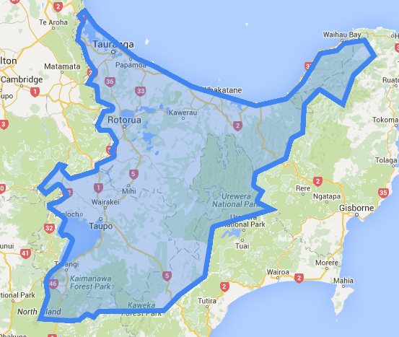

Bay of Plenty Region

* As per Ministry of Health guidelines “a person with a disability is someone who has been assessed as having a physical, psychiatric, intellectual, sensory, or age related disability (or a combination of these) which is likely to continue for a minimum of six months and result in a reduction of independent function to the extent that ongoing support is required”
Enquiries - Phone: 0800 654 546 / 07 578 6546 Email: info@baytrust.org.nz

Dillon Scholarship Application form
First Name:_____________________ Last Name:__________________________ Mr ☐ Mrs☐ Miss ☐ Ms ☐
Date of Birth: ___________
Contact Details (Bay of Plenty base) / Address
__________________________________________________________________________________________________
Home Phone: _____________________________ Mobile Phone: _______________________________
Home email: ______________________________ Study email: _________________________________
Preferred method of contact: ☐ Home Phone ☐ Mobile Phone ☐ Text / Email (home or study)
Alternative person contact:
Name:______________________________________ Relationship to Applicant___________________________
Address: _________________________________________________________________________________________
Phone (Landline): __________________________________ Mobile:________________________________________
Nature of Disability: ________________________________________________________________________________________________________________________________________________________________________________________________________________________________________________________________________________________________________________________
Educational qualifications to date: ________________________________________________________________________________________________________
Proposed Tertiary Institution: ______________________________________________________________________________
Proposed course(s) and length of course (number of years): ________________________________________________________________________________________________________
☐ Scholarships may be made public, please tick if you would be prepared to be interviewed and your story be publicised.
Please supply any other income sources you expect to receive during your study.
________________________________________________________________________________________________________________________________________________________________________________________________________________
Is there anything else you would like to tell us about?
________________________________________________________________________________________________________
Please include: -
- ☐ Formal advice of your course costs (if any)
- ☐ Letter of acceptance into your course
- ☐ A current medical certificate stating nature of condition
- ☐ A covering letter telling us why you should receive a
Scholarship and explaining how your condition will affect
your study together with what additional support you have.
- ☐ Bank deposit slip in the name of the applicant
- ☐ Photograph of yourself (optional)
- Where did you hear about the Dillon Scholarship?
☐ Advert in paper ☐ Friends/Family ☐ Education Provider ☐ Other
Applications must be received by 7 December. Late applications will not be considered.
I agree to abide by the requirements of the Trust as stated in the Scholarship guidelines.
Signature______________________________ (Applicant) Date ____________
Completed application form to be scanned and emailed to info@baytrust.org.nz or post with accompanying documents to BayTrust, PO Box 13322, Tauranga 3141.

